Please note that supplementary materials are available on the journal website for Sibbaldia the International Journal of Botanic Garden Horticulture. Files are as supplied by the author and have not subjected to the Journal’s editorial processes.
Supplementary tables for Bringing Australia’s vulnerable Baw-Baw Berry, Wittsteinia vacciniacea F.Muell., into cultivation
Virginia G. Williamson, Anthony R. Rendall, Li-Hsin Wu and Megan J. Hirst
Table S1. Propagation results from the five Wittsteinia vacciniacea collection sites.
Jiffy Preforma Plugs; Hormone is Clonex® Rooting Hormone Gel Purple; vermiculite:perlite 3:1 mix.
Table S2. Thermogradient design showing 196 coloured cells (green, red, yellow, blue) which each hold a 35mm Petri dish of 10 Wittsteinia vacciniacea seed collected from Mt Baw Baw. Treatment one (control): 980 fresh seed soaked for 8 h in deionised water and sown onto 98 plates (green & blue cells). Treatment two: 980 fresh seed soaked for 8 h in gibberellic acid (GA₃)(red & yellow cells).
Table S3. Model selection comparing candidate models of predictors to explain germination rate with respect to temperature, pre-treatment, and week. Table includes: the number of parameters (K), Log-Likelihood (LL), Akaike Information Criterion corrected (AICc), delta AIC (∆AIC) and AIC weights (AIC ώ). Variables include pre-soak treatment (pTreat), week since the start of experiment (Week), thermogradient temperature (temp). s(x) represents where a smooth term has been applied.
Table S4. Percentage contribution and permutational importance of the top climate variables influencing the distribution of Wittsteinia vacciniacea in Australia, and within the Köppen-Geiger climate.

Table S1
Wittsteinia vacciniacea  site | Nursery treatment |  | Number propagated | Root initiation |  | Propagation success  (%)
Mt Baw Baw | Preforma Plugs & hormone |  | 28 | 27 |  | 96.4
Mt Baw Baw | Prefoma Plugs & no hormone |  | 25 | 20 |  | 80.0
Mt Baw Baw | vermiculite:perlite 3:1 & hormone |  | 35 | 13 |  | 37.1
Mt Baw Baw | vermiculite:perlite 3:1 & no hormone |  | 25 | 6 |  | 24.0
Mt Erica | Preforma Plugs & hormone |  | 26 | 21 |  | 80.8
Mt Erica | Prefoma Plugs & no hormone |  | 23 | 18 |  | 78.3
Mt Erica | vermiculite:perlite 3:1 & hormone |  | 28 | 5 |  | 17.9
Mt Erica | vermiculite:perlite 3:1 & no hormone |  | 25 | 3 |  | 12.0
Mt Donna Buang | Preforma Plugs & hormone |  | 35 | 29 |  | 82.9
Mt Donna Buang | Prefoma Plugs & no hormone |  | 32 | 26 |  | 81.3
Mt Donna Buang | vermiculite:perlite 3:1 & hormone |  | 25 | 17 |  | 68.0
Mt Donna Buang | vermiculite:perlite 3:1 & no hormone |  | 25 | 13 |  | 52.0
Lake Mountain | Preforma Plugs & hormone |  | 17 | 14 |  | 82.4
Lake Mountain | Prefoma Plugs & no hormone |  | 18 | 16 |  | 88.9
Lake Mountain | vermiculite:perlite 3:1 & hormone |  | 17 | 12 |  | 70.6
Lake Mountain | vermiculite:perlite 3:1 & no hormone |  | 17 | 14 |  | 82.4
Mt Cobbler | Preforma Plugs & hormone |  | 40 | 25 |  | 62.5
Mt Cobbler | Prefoma Plugs & no hormone |  | 40 | 24 |  | 60.0
Mt Cobbler | vermiculite:perlite 3:1 & hormone |  | 40 | 28 |  | 70.0
Mt Cobbler | vermiculite:perlite 3:1 & no hormone |  | 40 | 10 |  | 25.0
 |  | Total | 561 |  | 341 |  | 60.8

Table S2
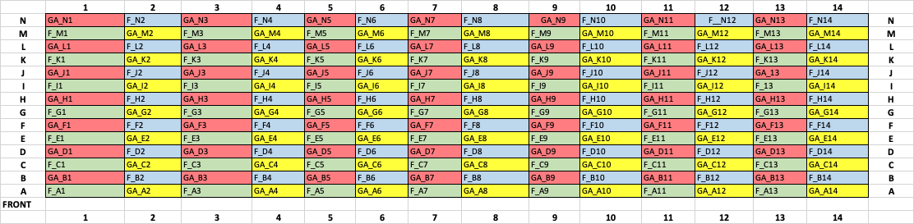

Table S3
Model | K | LL | AICc | ∆AIC | AIC ώ
Germ ~ pTreat + Week + s(Temp) | 80 | -62.746 | 295.8 | 0.00 | 0.476
Germ ~ pTreat + Week + s(Temp) + s (Temp x pTreat) | 83 | -59.300 | 296.1 | 0.25 | 0.420
Germ ~ Week + s(Temp) + s (Temp× pTreat) | 81 | -63.066 | 298.9 | 3.04 | 0.104
Germ ~ pTreat +s(Temp) + s (Temp × pTreat) | 72 | -167.703 | 488.0 | 192.21 | 0.000
Germ ~ 1 | 94 | -181.217 | 563.7 | 267.84 | 0.000

Table S4
Region | Variable | Percent contribution | Permutation importance | ROC of AUC
Australia-wide | Isothermality | 45.2 | 18.8 | 0.998
 | Mean diurnal temperature range | 17.2 | 19.6
 | Temperature of coldest quarter | 15 | 61.5
 | Maximum temperature warmest week | 14.7 | 0
 | Precipitation of coldest quarter | 4.9 | 0.1
 | Precipitation of driest quarter | 3 | 0.1
 | Precipitation of wettest week | 0 | 0
Köppen-Geiger | Isothermality | 75.9 | 42 | 0.985
 | Mean diurnal temperature range | 17.1 | 45.8
 | Temperature of coldest quarter | 3.1 | 6.6
 | Mean temperature warmest quarter | 2 | 0
 | Precipitation of warmest quarter | 0.9 | 1.8
 | Annual Precipitation | 0.5 | 1.9
 | Precipitation of driest week | 0.5 | 2
 | Precipitation of coldest quarter | 0.1 | 0
 | Precipitation of wettest week | 0 | 0

