Please note that supplementary materials are available on the journal website for Sibbaldia the International Journal of Botanic Garden Horticulture. Files are as supplied by the author and have not subjected to the Journal’s editorial processes.
Supplementary figures for Bringing Australia’s vulnerable Baw-Baw Berry, Wittsteinia vacciniacea F.Muell., into cultivation
Virginia G. Williamson, Anthony R. Rendall, Li-Hsin Wu and Megan J. Hirst
Figure S1. Outline of the state of Victoria showing the current distribution of the Baw-Baw Berry (Wittsteinia vacciniacea) highlighted in green, accessed from Flora of Victoria (Vicflora, 2024). Note the disjunct population on the most southern point of Victoria, at Wilsons Promontory.
Figure S2. X-ray image of a random sample of 56 cleaned Baw-Baw Berry (Wittsteinia vacciniacea) seed. Filled seed appear white; non- or partially-filled seed is darker. From this image the calculated fill rate is 91%.
Figure S3. Wittsteinia vacciniacea, showing the abundant adventitious roots and suckering habit. No treatment had been given to this plant. (Photo: V. Williamson)
Figure S4. Young plants of Wittsteinia vacciniacea which had germinated after the berries had been washed downstream at the Mt Donna Buang site. (Photo: V. Williamson)
Figure S5. Response curves of Wittsteinia vacciniacea distribution considering an Australia-wide model.
Figure S6. Response curves of Wittsteinia vacciniacea distribution considering a Köppen-Geiger model.
Figure S1.
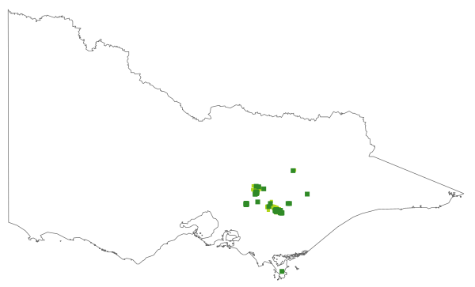

Figure S2.
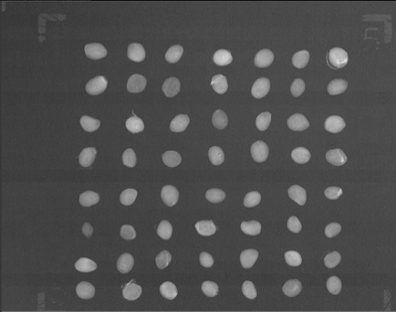

Figure S3.
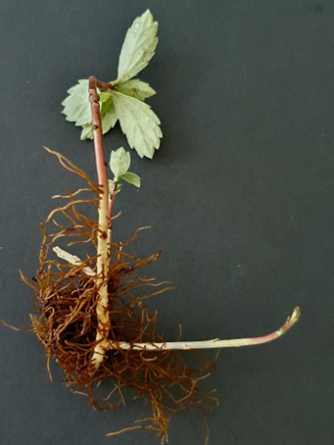

Figure S4.
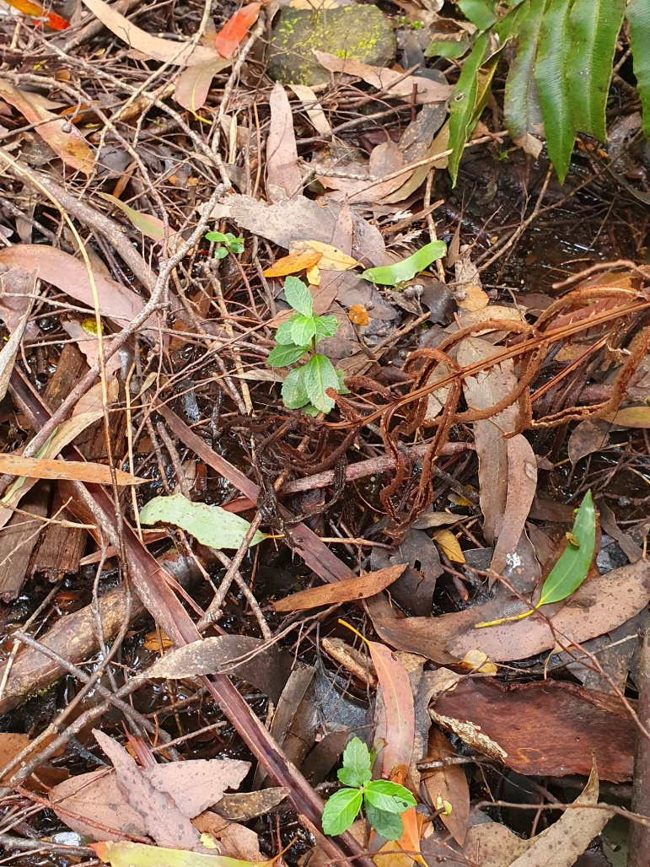

Figure S5.

Figure S6.

