SUPPLEMENTARY MATERIAL B

Correlations among all metrics included in the endangerment value matrix, for target species in four priority genera at The Morton Arboretum: Malus, Quercus, Tilia and Ulmus. The top right section of the matrix shows the correlation coefficient (r) for each pair. The distribution of the data is shown on the diagonal. A significant correlation (p value less than the alpha value of 0.05) is signified by one or more red stars (* p value is <0.05, ** is <0.01, *** is <0.001). The first chart (1) shows results for all target species, while subsequent charts (2-5) show results for target species in each genus separately. For Malus and Tilia, very few target species had climate change and pest/disease vulnerability data, so for these genera the climate change and pest/disease vulnerability metrics were not scored.

- All target species (182)
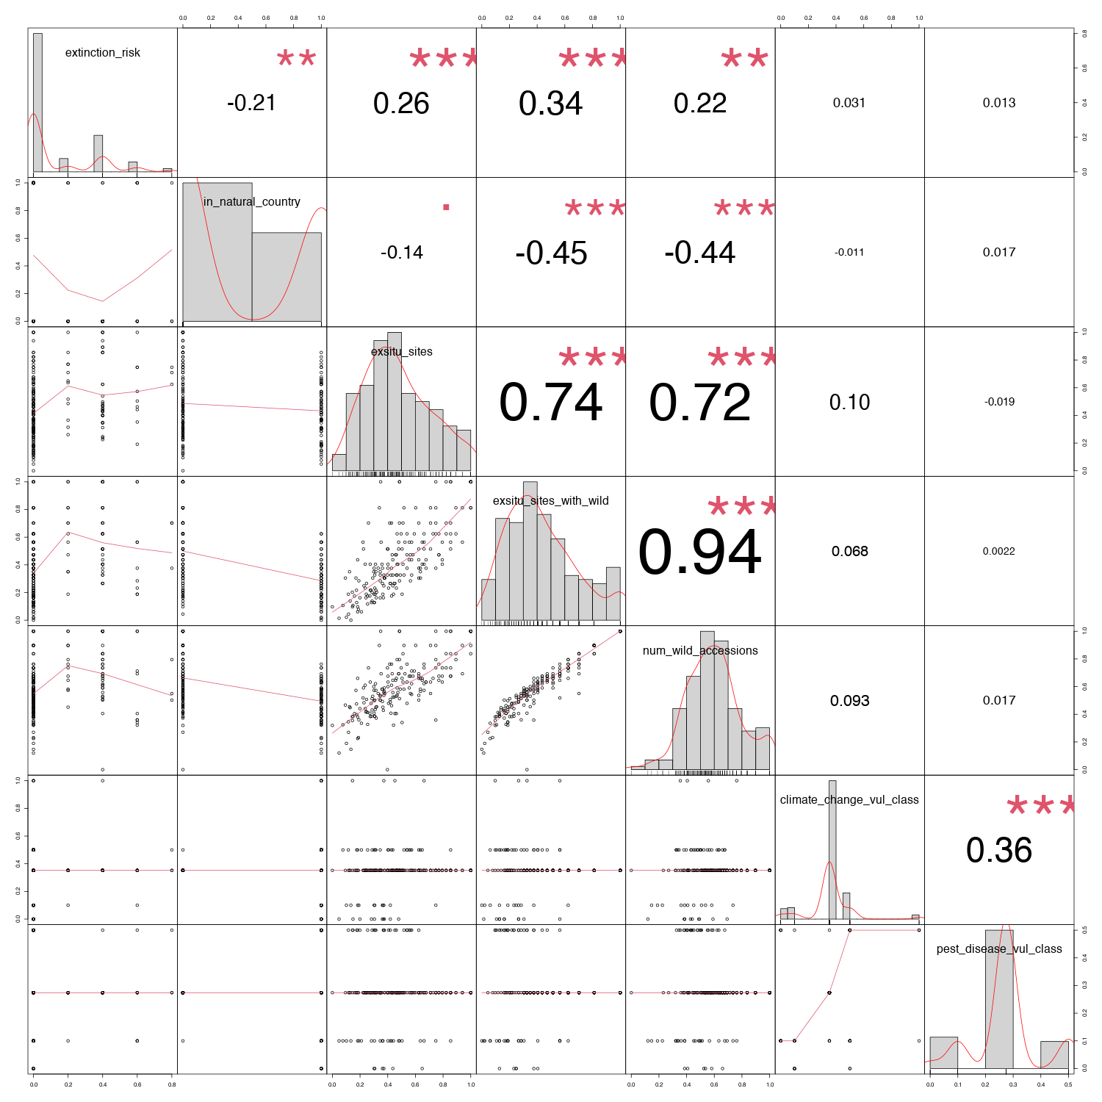

- Target Malus species (34)
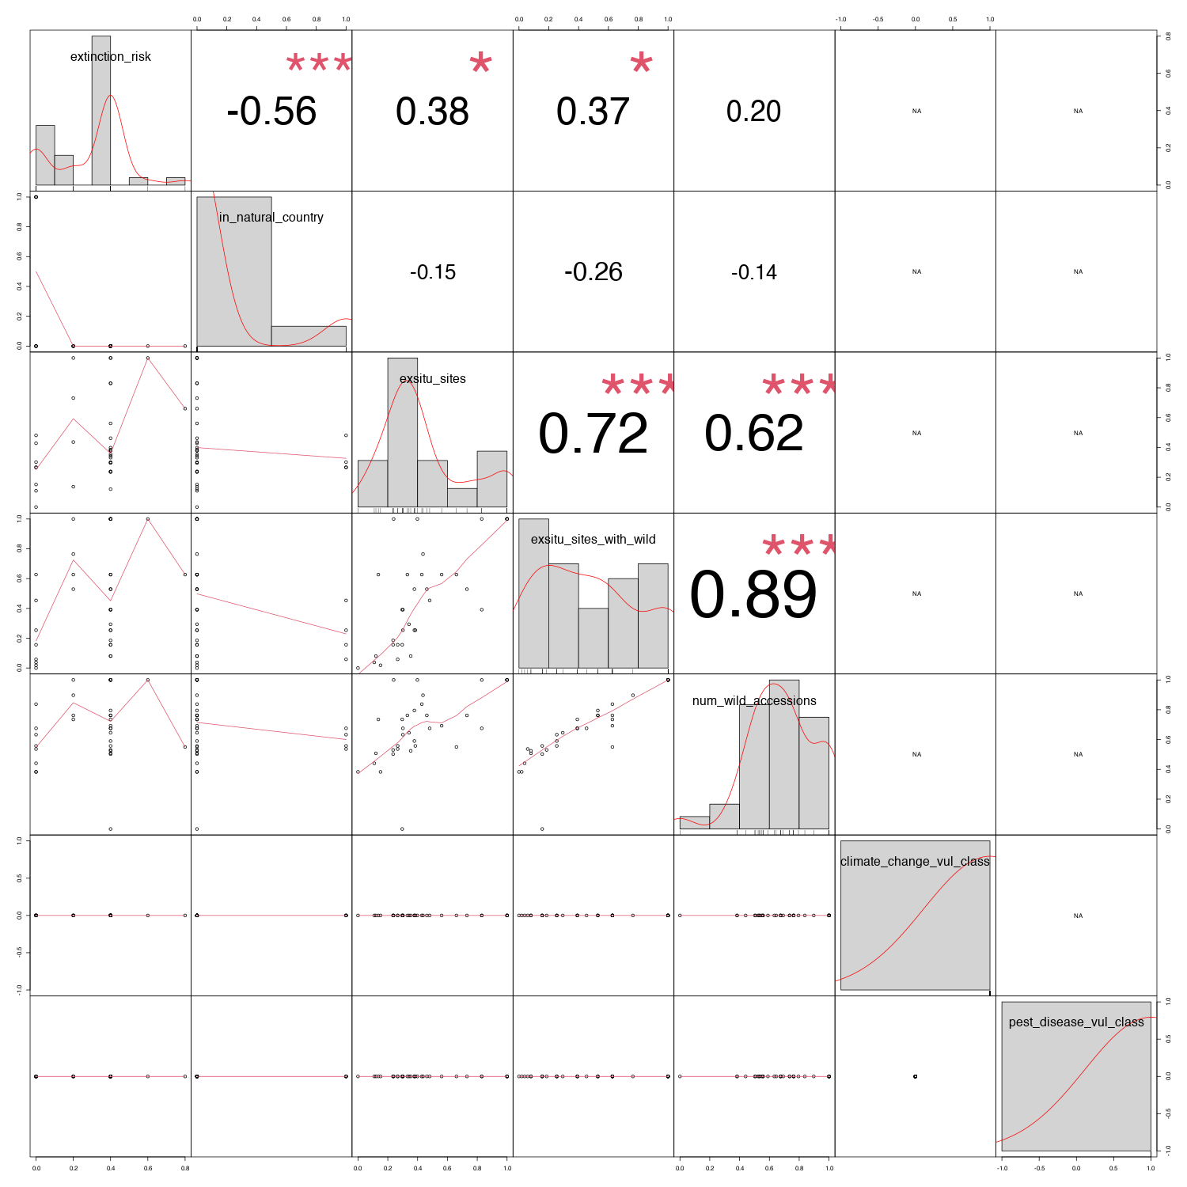

- Target Quercus species (100)
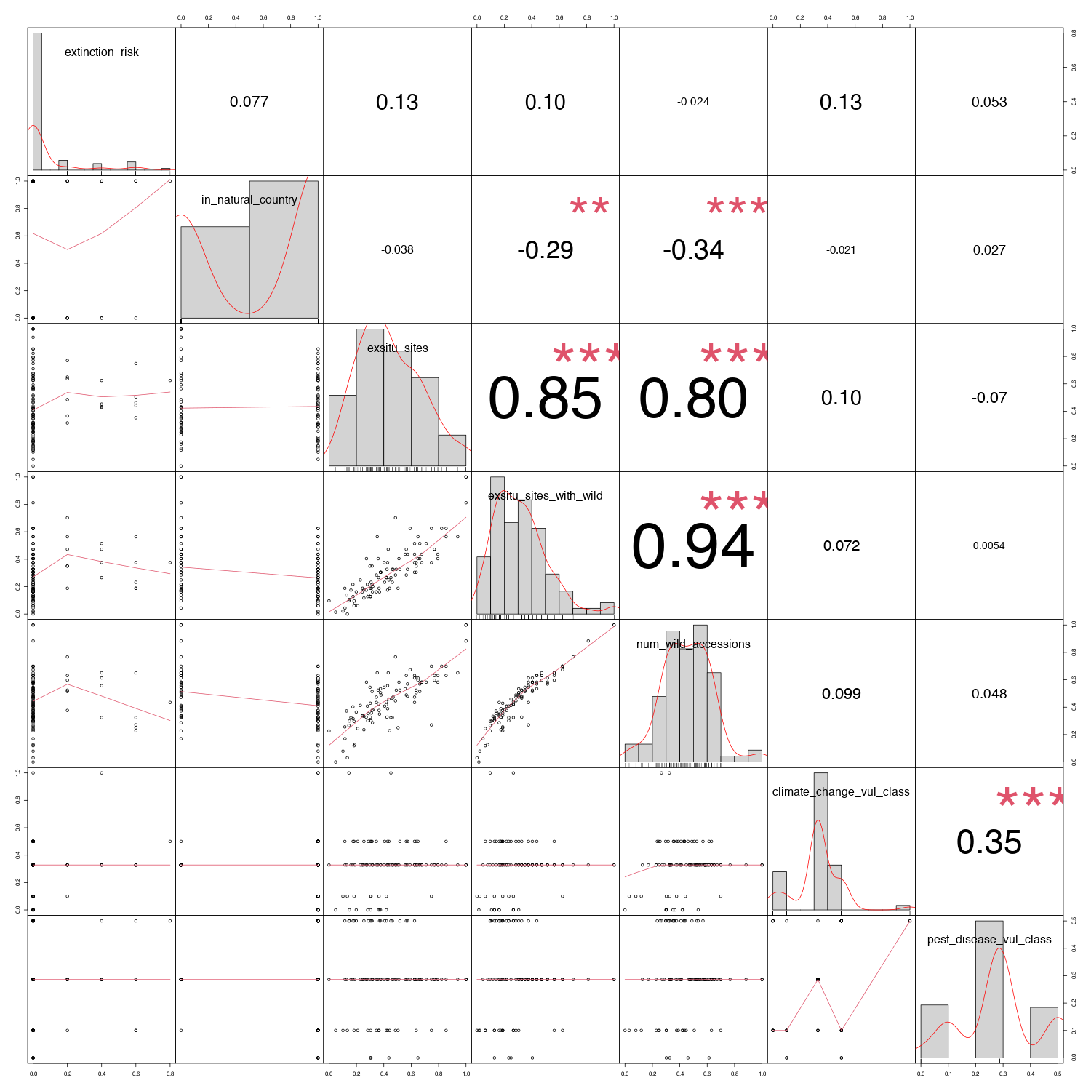

- Target Tilia species (18)
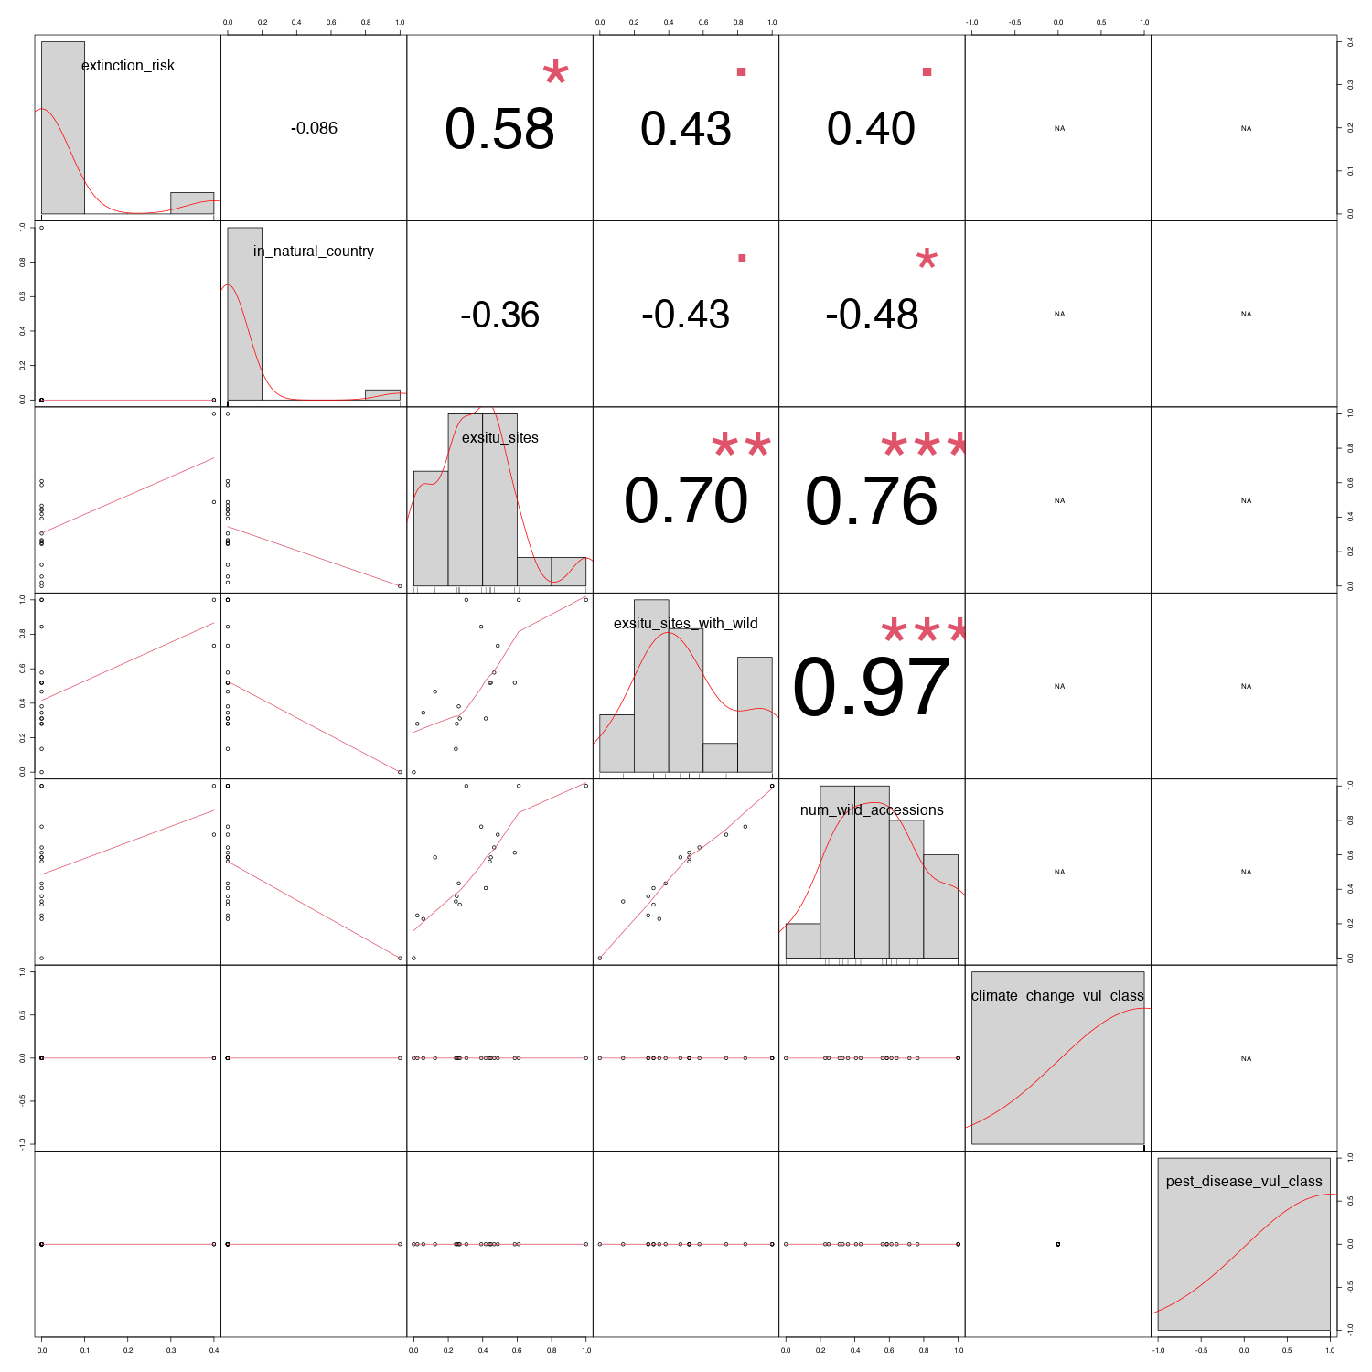

- Target Ulmus species (30)
